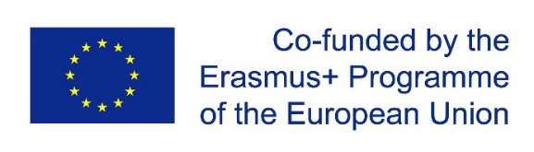

Recommendations for Involving Adults from Disadvantaged Backgrounds in Education

Project ODEon - “Openness to diversity through community education””
(Nr. 2016-1-LV01-KA204-022704)

Riga, Paphos, Ferrara, 2017

Introduction

The aim of developing the recommendations was to gather information on approaches and solutions that allow involving adults from different disadvantagedbackgrounds in education. It is well known that people who are the least motivated to study are those who have low qualification and low-paid jobs alongside other representatives of similar groups.The situation could not be changed neither through diversification of educational offer nor through quality improvement. There should be a deeper understanding of reasons behind the obstacles that prevent these groups from getting involved in learning,and ideas on how to overcome them.
The strategic partnership of three representatives coming from three countries has been developed in the framework of the project ODEon. These include Kurzeme Planning Region (Latvia), a non-governmental organisation OPEI (Cyprus), and a social theatre NUCLEO (Italy). Partners shared a common idea that adults from disadvantaged backgrounds need community support. The community is the nearest and the most accessible support environment. In contrast to individual projects, the community is able to provide a continuous support, which is essential for people with low motivation. At the same time, one of the aims of adult education is the integration of a person into society, hence into the community. Therefore, in the framework of the project the issue of involving adults in education was addressed as an issue of interaction possibilities between adults from socially disadvantaged backgrounds and their local community.
The project allowed outlining the specificities and advantages of an approach offered by each partner.
Adult education in Cyprus follows the needs-based approach where the process is simplified as much as possible and the bureaucracy is being avoided. The process relies on the initiative of education providers, building cooperation based on mutual trust between public bodies and adult education providers.
An important actor in the sector of adult education in Italy is the social theatre whichuses the drama method in its various forms when working with migrants, prisoners, the mentally disabled and other adult target groups. The activities of the theatre serve as a certain preparation that contributes towards involving these groups in education. They help to raise self-esteem, promote a sense of freedom and motivation for self-empowerment as well as a sense of belonging to the community.
The approach used in Latvia for involving adults in education relies on the cultural and historical traditions of the community and the promotion of self-organised learning among different social groups. Involving people in finding solutions to their own problems helps to improve their sense of self-efficacy, motivation to learn andto develop and improve their own life and the surrounding environment.
These recommendations are based on the partners’ shared understanding of the difficulties and possible solutions rather than on the summary of individual partners’ experiences.

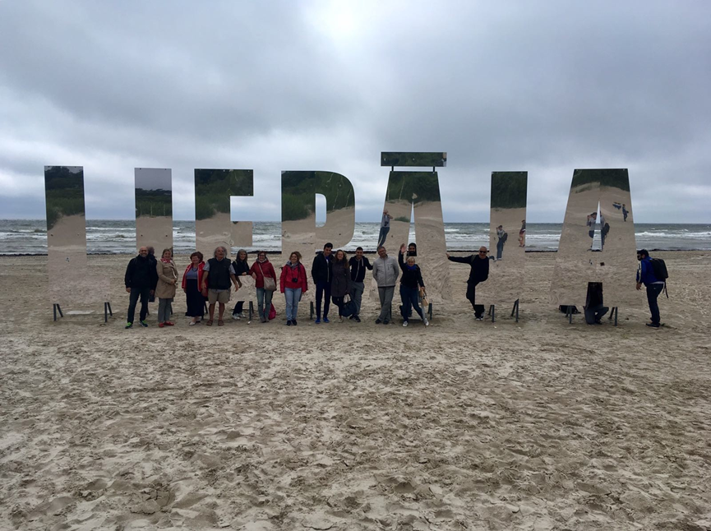
Figure 1Participants of the ODEon project during a learning session in Latvia

General recommendations for involving adults in education
- Organise activities for community integration that are based on common values and shared efforts in overcoming common problems.

- Involve in the implementation of adult education services more representatives of non-governmental adult education providers that are aware of local needs.

- Organise open calls for projects that could offer educational activities for adults from disadvantaged backgrounds, supporting creativity and initiative of adult education providers.

- Support the development and functioning of the social theatres.

- Establish centres for citizens’ initiatives at local government level. Identify community resources for supporting and organising educational activities, and coordinate their cooperation.

- Use local cultural and historical traditions for involving adults in education and develop new multicultural traditions.

- Develop information channels and vary the manner in which information is delivered aiming to reach everyone.

- Study the needs of specific target groups and adapt educational activities for these groups according to the findings.

- Ensure the continuity of adult lifelong learning. Develop a system of educational activities that would result in the increase of adults’ self-confidence, the development of their learning motivation and would bring the first learning success encouraging adults to continuethe educational path.

- Acknowledge the belonging and the contribution of an individual or a group to the community in order to sustain their intentions for further growth. Develop the community’s function to act as an education support environment.

Recommendations for involving adult target groups in education

At the beginning of the project, the partners have identified those target groups from disadvantaged backgrounds that are currently topicalfor each country. The results are summarised in Table 1. The mark ‘+’ shows that the target group is pertinent in the given country. The summary is based on the subjective experience of partners and is not supported by statistical data.

No. | Target group | Latvia | Cyprus | Italy
 | People with mental disabilities | + | + | +
 | Prisoners and former convicts |  |  | ₊
 | Migrants and refugees | + | + | +
 | Young single mothers | + |  | +
 | Physically disabled persons | + | +
 | Seniors | + | + | +
 | Visually impaired persons | + |  | +
 | Inhabitants of remote rural areas | + | +
 | Low-skilled workers |  | +
 | Persons with autism | + | +

Table 1Adult target groups from disadvantaged backgrounds that are currently topical in partner countries

As seen from the table, several target groups are topical in each partner country. These are people with mental disabilities, migrants, refugees and seniors. At the same time, prisoners and former convicts are considered to be a topical target group only by the Italian partner, while low-skilled workers – by the Cyprus partner. Even if one target group is considered to be topical by several countries it does not mean that these countries face the same situation. For instance, migrants and refugees are considered to be a topical target group in Italy which faces the large influx of refugees and provides special educational programmes. Latvia and Cyprus treat this issue as potentially important. In Cyprus some refugees are enrolled in educational programmes, however, these are general programmes rather than programmes developed specifically for refugees. Despite these differences, during the discussions the partners developed a common understanding on the problems related to these topical target groups. The four most topical target groups were selected during the learning sessions. The project participants worked in mixed groups and analysed the obstacles which prevent the members of these target groups from getting involved in education, and defined possible solutions. The recommendations for working with these four target groups developed during the sessions are outlined below.

Target group: mentally disabled persons

Problems | Recommendations
Mentally disabled persons lack self-initiative and self-confidence. They have a passive attitude waiting while others will solve their problems | Use the drama method and establish theatre groups in order to improve self-initiative and self-confidence.  Transfer responsibility to group participants, make them responsible for themselves, and foster their social skills.  Produce individual development plans based on SWOT analysis of personal capacities emphasizing the strengths. For example, the analysis allowed identifying that a girl is good at drawing in a 3D format. Having this special vision, she can work as an architecturalassistant.
Educators who work with this target group have poor methodological competences | Organise professional development programmes for adult educators. Assign the role of the educator to the members of the target group. Include the acquisition of a simple language in the content of the programme.
Educators have a distant attitude towards the participants; they lack positive expectations of results | Let educators temporary exchange places with the participants in order to make them depend on them, understand what it means to be in their shoes and become aware of positive capacities of these people.
Educators have professional burnout | Organise regular educational activities for educators that focus on raising awareness of personal potential, personal orientation, as well as on experiencing and balancing different social roles, anddeveloping emotional intelligence.

Target group: migrants

Problems | Recommendations
Local authorities have a formal approach. There is no careful study of migrants’ competences and abilities that would serve to develop an integration plan that would be as close as possible to the needs and aims of a single person | Develop a welcoming protocol that will help local authorities to get information about specific competences of migrants, and develop a more effective integration plan. For instance, questionnaires, theoretical and practical tests, internship periods.
Migrants have difficulties to learn a new language. They lack self-confidence in using the language of the host country | Practice language in non-formal groups, such as families, non-profit organizations, municipalities.  Help to build self-confidence using theatre groups, artistic work, culture and crafts.
Traditional teaching methods (such as lectures, seminars, etc.) are not effective means for the integration of migrants | Ensure timely identification of skills, aims and learning traditions of the participants of the training. Use different learning forms in order to stimulate learning and practical activity. For instance, theatre classes, practical work.
Integration of migrants is impeded by negative stereotypes of the host country’s inhabitants | Reduce negative stereotyping with the help of experience exchange and cultural initiatives.
Migrants’ experience and educational background are not sufficiently recognised in host countries which creates barriers towards their integration in the community and the labour market.  The rules for the validation of learning are not adapted for valorisation of migrants’ background experience | Establish flexible system for the recognition of migrants’ education. Develop the methodology for identifying skills acquired through practice.  Examine skills required for changing lifestyle, moving to another country and adapting to a new culture and include them in the list of the recognised learning content. Develop and issue diplomas that certify migrants’ practical competences.
Educators lack competences to work with migrants | Organise courses about different cultures, promote exchange activities with educators coming from other countries.  Include the module on alternative educational practices in the educators’ professional development programmes.

Target group: Inhabitants of remote rural areasfromsocioeconomically disadvantaged backgrounds

Problems | Recommendations
Poor communication between educators and participants of the training activities. Educators are insensitive to the group, they lack enthusiasm | Pay timely attention to the preparation of educators, raising their understanding of the rural regions and areas (inhabitants, means and influence). Develop educators’ sensitivity to problems in order to help them identify impulses manifested in participants’ behaviour and respond to them duly and constructively. Organise interactive courses to ensure more active involvement of the audience in learning. From time to time during the training allow participants exchange places with the educators so that each of them could experience the process from another point of view thus making that point of view more understandable for them.
Inhabitants of the rural areas are afraid of the new. They have a lot of prejudices | Encourage cooperation among active members of the community and support their educational activities in order to change the attitude of other members towards the new through the power of a good example. Integrate the development of critical thinking and problem solving skills in the training activities.
Inhabitants of remote rural areas from socioeconomically disadvantaged backgrounds do not believe education could be useful to them | Examine household, social and economic needs of the rural community and organise training activities with practically useful content. For instance, programmes useful for running a family business. Develop consultancy services in rural areas integrating them in everyday community activities.
The members of the target group are not interested in educational opportunities, they are not aware of opportunities available free of charge | Use effective communication channels for disseminating information in rural areas so that it could reach everyone. Provide explanations, employ persuasion and inspiration.
Rural areas suffer from a limited choice of educational activities | Examine the potential of libraries, museums, cultural centres, community centres and educational centres to provide possibilities for the improvement of inhabitants’ knowledge and skills. Contribute to the development of educational activities provided by these organisations. Activities organised in museums, open lectures in libraries, etc.

Target group: seniors

Problems | Recommendations
Older people distance themselves from active social processes. They do not quite understand and accept new life and young people | Create groups where different generations can share their knowledge. Seniors could teach the young generation some things useful in everyday life (such as fixing a bike, gardening, and small carpenter work). The young could help with the use of mobile phones, internet, Skype, etc.  Young people have more confidence and determination; they are more skilled in remembering facts. Middle-aged people are more responsible and pay more attention to details. Older generations need reintegration because they are more passive and less flexible. Ideally, the groups should include representatives of different age groups in order to boost the strengths and compensate for the weaknesses of each group.
Older people lack motivation to take part in adult education and social activities | Organize educational activities outside educational institutions.Start with involving seniors in practical courses where they feel more at ease. Becoming familiar with the school environment and getting positive experience should facilitate their participation in further courses.  Organize interest group activities based on their own desires and when it is necessary.  Establish interest groups for seniors – dance, art, music, etc.
Seniors often face practical problems that prevent them from getting involved in education | Practical problems (for example, it is difficult for me to reach the school because it’s too far, too late at night, etc.) could be solved by involving a network of volunteers who could provide transport. The same solution concerns physical problems.  Set minimum membership fees from EUR 5.00 to EUR 10.00 per year.  Develop volunteer work for seniors. Seniors who work as volunteers get practical support, such as tickets to concerts, events or trips.  With the help of adult education centres, senior clubs and other relevant organisations organise senior volunteer exchange trips with other countries.  Use social entrepreneurship activities (for instance, ladies make clothes, blankets).

Methods used by partners for involving adults

1. Organising adult education in the public centres – Nica (Nīca) County experience

The county of Nica (Nīca) is located in the southwest of Latvia next to the sea. It is composed of nine villages that altogether count around 3500 inhabitants. The main adult target audience is people living in the remote rural areas. In order to involve these inhabitants in education and training activities the Adult Education Centre located in the centre of Nica organises different seminars and courses. However, the inhabitants of remote rural areas face difficulties to reach them. The county municipality established public centres with the aim of ensuring a broader involvement of adult population in education and training. There are two centres available in the county of Nica, one in Kalniski village (Kalnišķi) and another one in Jurmalciems village (Jūrmalciems). Both of them have been operating for more than five years. A new public centre is being established in Grinvalti village (Grīnvalti). The centres function with the support of the county council. The public centres have the library; once or twice a month there is the possibility to have an appointment with a doctor in the facilities of the centre. Moreover, there is an access to computers and printing equipment. The centres are managed by a group of members. The participants discuss the needs, put forward ideas and plan activities. The public centres have been actively involved in projects, as a result of which they were able to both purchase sport equipment and build different associated facilities close to the centres, such as a gazebo and an outdoor fireplace. Physical activities have also been organised. The public centres also get involved in the cultural life of the county. This year, the centres organised the following activities: “Herring Festival in Jurmalciems village” (”Reņģu svētki Jūrmalciemā”), “Ancient bonfire night in Jurmalsciems village” („Seno ugunskuru nakts Jūrmalciemā”), “Mushroom picking with a mycologist (mushroom specialist)” („Sēņošana kopā ar mikologu”). The public centres sustain friendly relations with each other and share experience. The centres organise different activities, such as sewing, knitting, decoupage, beading, etc. These are informal and non-formal educational activities organised by the centres.
The public centres can function only when people who are eager to do something want to be active. The villages with the functioning public centres do not feel isolated; on the contrary they feel to be part of the county. They are highly appreciated because they serve as a support and help for the Nica county council. The functioning of the public centres is an example of a good practice of involving inhabitants in the community education.
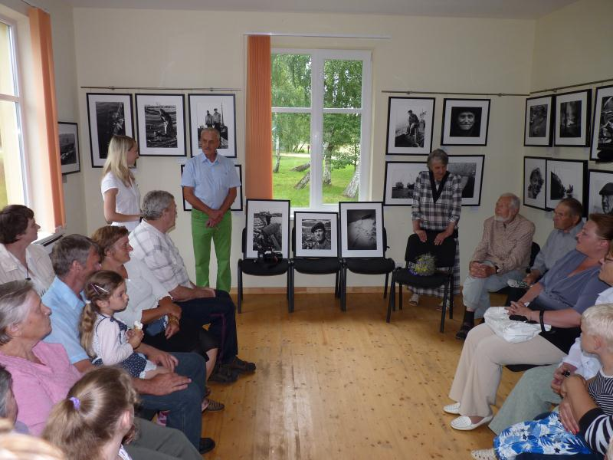
Figure 2 The public centre in Jurmalciems village (Jūrmalciems)

2. Soul appeasement garden for the blind
An example we are proud of in the region of Kurzeme is the Liepaja Society of the Blind (“Liepājas Neredzīgo biedrība”). When a human being loses sight he has to learn everything from the scratch, starting from basic skills. Alongside this problem, a person is overtaken by a depressive mood and the feeling of isolation. In order to help these people it is important to increase their motivation, help them to believe in themselves and create conditions for their self-expression. This is exactly the approach adopted by the Liepaja Society of the Blind.
The aim of the Society is to foster the improvement of the quality of life of blind or poor sighted persons as well as persons with other types of disability, to foster their integration in the society and to unite persons with disabilities and motivate them to take active part in the development of civil society. The Society works to ensure the involvement of people with disabilities in active participation, making sure everyone is involved, feels useful and belonging to a group.
The Liepaja Society of the Blind coordinates the non-governmental cooperation network of disabled persons of the city of Liepaja and its district. The network unites 16 organisations. The members of the network hold regular meetings in order to discuss current issues, receive support and initiatives, as well as to agree on the further steps for solving any problems. The Society has its own journal entitled “A light in the darkness” (“Gaisma Tumsā”) which is published in a regular format for the sighted, Braille format, and audio format.
The facilities of the Society of the Blind are equipped in line with the universal design. The clients have the possibility to use the transport which belongs to the Society and the service of the assistants. If required, they can be offered accommodation.
Within the facilities of the Society the disabled persons have the possibility to develop their skills in household activities and housekeeping. They have courses on burling and mending, floral design, they learn to use computers and play the piano. Different sport activities are also organised, such as activities in a gym, Nordic walking, and board games competitions. There is the possibility to use fitness equipment and get involved in interpersonal communication and support groups.
The persons with disabilities do not only have the role of the participants in all these activities, but they also take active part in their organisation, which is the reason why these activities flourish. The participants get involved in the repairing works of the facilities and their improvement, they organise sport games and teach others. Each and every participant can find the domain where he can put in practice his skills and feel satisfied with the result.
The Society is especially proud of “Soul appeasement garden” (“Dvēseles veldzes dārzs”), which is the social rehabilitation and information centre in the countryside. It is a property in the countryside where persons with disabilities cultivate and harvest fruits and vegetables and make use of them for their purposes. The Society also owns domestic animals, such as sheep, chicken, rabbits and cats. Volunteers together with the persons with disabilities get involved in cleaning and maintaining the surrounding area, preparing soil, cutting branches, planting, sowing, bird watching, etc.
The garden has its “Park of senses” (“Sajūtu parks”) where blind people can recognise flowers by smell and touch. Some paths have been created in the forest, the path of herbs and the “barefoot path”, as well as paths with different coating. Fitness equipment is installed outside, together with a game set “Outside Chess and Draughts” and a hedge maze. The works have been undertaken to install a swimming pond suited to regular active swimmers, people in a wheelchair and elderly people.
The aim of improving and adapting the “Soul appeasement garden” information centre is to make the developed services available to anyone living in the near or distant area, including tourists, families with children and people with different types of disabilities.
The Society’s key to success is the belief in human abilities and the fact that everything, including learning environment, content and methods, is adapted to the specific needs of the target group.
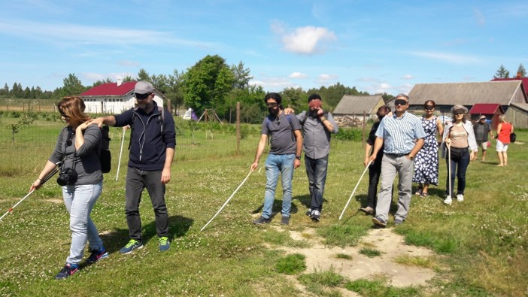
Figure 3 The participants of the ODEon project in the“Soul appeasement garden” during the learning session in Latvia
3. Coordination of community resources for adult education – Aizpute County experience
The county of Aizpute is a small rural area in Kurzeme Planning Region. The county has a Lifelong Learning centre which is an adult education support unit.
The operational programme of the centre includes several important objectives:
- Improve competence of adult educators; reinforce the capacity of the municipality in the domain of adult education.
- Foster the cooperation of adult education institutions that work with adults with limited abilities.
- Identify best practices in working with different social groups and develop recommendations on involvement of disadvantaged population in education.
In order to reach these objectives, the centre actively cooperates with different organisations.
Taking into account that the population of the remote areas rarely attends the centre, the Lifelong Learning centre tries to involve them with the help of associations. Information days and seminars have been organised in cooperation with the Kurzeme associations of NGO support centres. For a number of years Aizpute county council has been issuing calls for tenders to the associations for educating the public, cleaning the environment and developing new initiatives. The most active association members have been invited for experience exchange visits to Saldus (Saldus) and Broceni (Brocēņi) in order to learn from positive experience, activate the public and strengthen their own association. The public has been educated about the activities of the associations.
One of the important target groups in the county of Aizpute is young people. Together with the Latvian Rural Advisory centre the Lifelong Learning centre has organised an education and training cycle “Support to young people of the rural areas to encourage entrepreneurship” (“Atbalsts lauku jauniešiem uzņēmējdarbības veicināšanai”). In the framework of this cycle young people had the possibility to take part in experience exchange visits to young entrepreneurs in the nearest counties. Together with the County Development centre, the Lifelong Learning centre carried out a project “Active and creative lifestyle for improving and promoting the quality of life of elderly people and young people with mental disabilities in the region of Kurzeme” („Aktīvs un radošs dzīvesveids bērnu un jauniešu ar garīgās attīstības traucējumiem un senioru dzīves kvalitātes uzlabošanai un veicināšanai Kurzemes reģionā”). One of the project activities was a creative and professional training camp for young people.
The Lifelong Learning centre involves other local authorities in educating the public. A number of activities aimed at the development of e-skills have been organised in cooperation with parish libraries, a county museum has been running creative workshops in the domain of the applied arts, and a county school has been offering a course cycle for families about a healthy diet.
Education of the community in the county of Aizpute is ensured through the activation of the local resources and coordination of their cooperation.

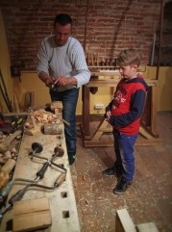
Figure 4The learning session in a woodwork workshop in Aizpute local history museum

4. Adult education in the context of ethnic culture – Alsunga County experience

Adult education in the county of Alsunga is focused on the preservation of ethnic identity. This is due to the fact that the county is inhabited by one of the Latvian ethnographic groups – Suiti (Suiti). This is a small Catholic community with its unusual culture that lives among predominantly Lutheran community in Kurzeme. The Suiti people have their special singing style known as Burdon singing (“burdona dziedāšana”), their rich wedding traditions, bright folk dress, Suiti language, local dishes, religious traditions and annual customs.
When the community of Suiti faced a decline, their representatives got actively involved in the preservation of their cultural heritage. As a result, the ethnic culture centre entitled ‘Suiti’ was established. It organises seminars and teaches traditions to children in the facilities of educational institutions of the county. The Suiti people use the elements of their culture in community activities, such as wedding rituals, games and plays, traditions of storytellers, family celebrations, working situations and everyday life.
Summer camps have been organised for the purpose of learning about community traditions. As a result of the associations’ initiatives the weaving studio was established and is fully functioning, classes teaching children to play Kokle (a string instrument) have been offered. Moreover, three international Burdon singing festivals have been organised. In their turn, the association “Suiti Craftsmen” (“Suitu amatnieki”) offer adults to acquire skills related to the artistic and craftwork sector.
In 2009, the Suiti cultural space was included in the UNESCO List of Intangible Cultural Heritage. In cooperation with various parties educational activities have been organised with the aim of practicing traditions in their diversity and making full use of all the opportunities to involve the local population in skills acquisition. The learning activities are also taking place in the form of the study and documentation of cultural elements, such as noting down the recipes, place names and folk songs.
The cultural and educational activities of the Suiti community have boosted the sense of dignity and self-esteem of their members. The Suiti community have managed to prove that the preservation of the cultural heritage can become a motivational factor and a driving force for the development of the municipality.
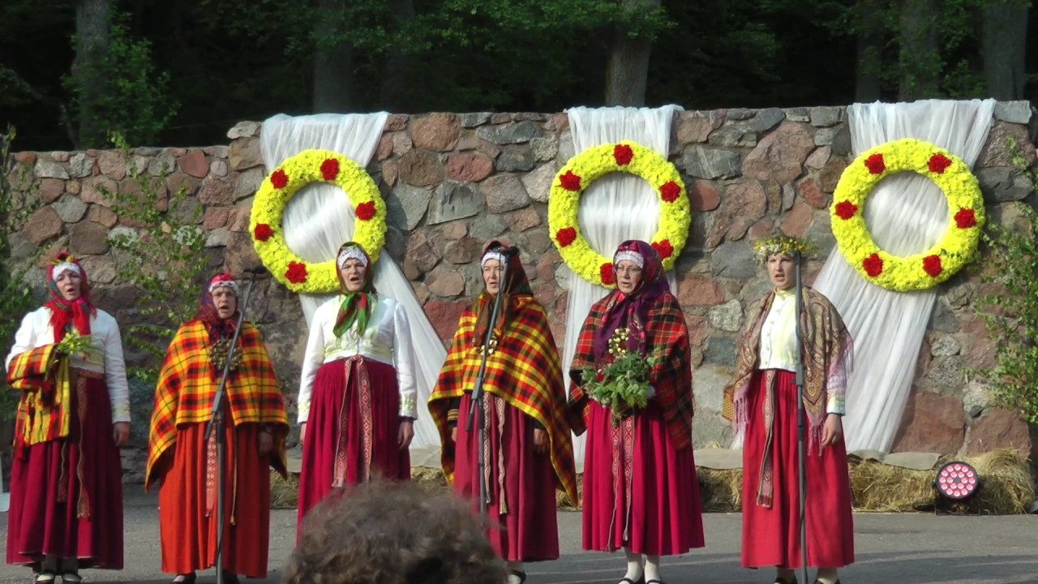
Figure 5The internationalBurdon singing festival on the Suiti soil in 2017

5. Methods for informing local community - Cyprus experience
Having long experience in working with young people and people living in rural areas, OPEI have witnessed a problem of access to education. One reason is the fact that people in rural areas have lower level of education and they have other priorities rather than sending their children to higher education institutions. Some groups of young people face family problems; they have parents of low economic and educational level and receive no guidance that would allow them to start or continue their education. This is the reason why many people have difficulty to find their way to education.

Issue at stake: Difficulty to find a way to education

This problem mainly affects the following groups:
- Inhabitants of rural areas;
- Socially vulnerable families;
- Young people
- Individuals with low income

OPEI values educational sustainability and thus pays significant attention to work with families. This is because family experience, culture and values to a great extent influence whether a child will get good education and will pursue it as an adult. Families from rural areas usually have lower educational level and do not provide any educational guidance or advice to their children. Children coming from socially vulnerable families are distracted from education rather than encouraged and guided towards it. Families with financial difficulties have less interest to encourage their children to pursue higher education. Young people lack experience to search their educational path on their own.

In order to solve this problem, OPEI involves the following resources:
- Educational consultants who provide guidance;
- Adult education centres;
- Lifelong learning institutes;
- Information centres in local communities.

OPEI adopted the following methods for informing the local communities:
- OPEI regularly sends informational reports on educational activities to local communities;
- OPEI publishes current information on the Paphos news portal;
- OPEI trainers/coaches take part in community meetings, inform about educational opportunities and answer questions. They also have experience in helping young people with training activities;
- OPEI has an agreement with volunteers who are community members and who distribute information in their workplaces and in daily communication;
- OPEI has signed a cooperation agreement with the PAPHOS 2017, European Capital of Culture;
- OPEI Career counsellors go to local communities, meet people and advise them on available educational activities;
- The OPEI uses community holidays and local events to carry out informational campaigns.

OPEI has several experienced trainers in education, such as a trainer certified by the National Accreditation body, a youth worker who organizes non formal courses for young people and career counsellors for higher education.
Our staff has regular contacts with local communities, local press and young people nationwide, and particularly with communities from rural areas.
OPEI encourages people and especially youngsters to participate in educational programs and activities, national seminars, youth activities, to attend adult education centres and the lifelong learning institutes. Young people and adults are informed about professions demanded on the labour market, EU-provided exchange opportunities and educational projects.

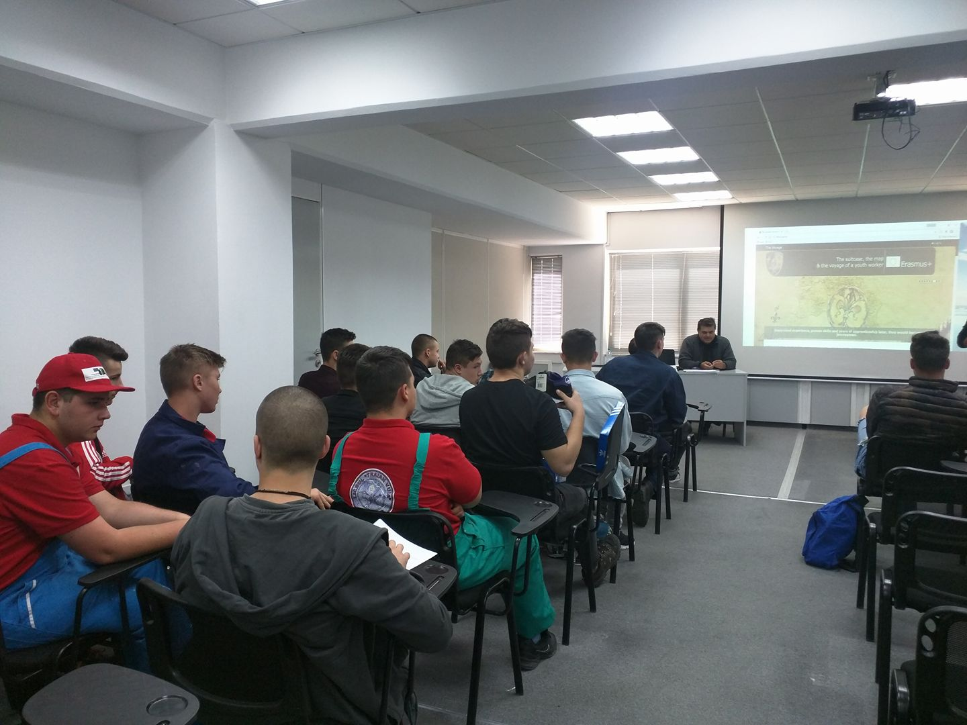
Figure 6 Informing young people about education possibilities in OPEI
6. Training activities for the involvement in the labour market - Cyprus experience
OPEI (Organization for the Promotion of European Issues) is involved in several programs that aim at people with fewer opportunities. One target group is unemployed people in rural areas who live far from economic centres of the island. The mostly affected are young people, people with low education level and low income. This target group needs to have access to subjects and training activities that can be useful for finding a job in their areas rather than general training courses.
The method adopted by OPEI to address this problem is to study the needs of the local communities and design courses with the relevant content that fits particular needs of the area.
A trainer working in rural areas should understand the needs and particularities of the area. The content of the designed courses must be relevant for the economic situation of the area, demands of the labour market, as well as motivation, life style and mentality of the inhabitants. OPEI has a successful experience in the implementation of such an approach.
The initial objective is to turn people towards learning and then create the atmosphere for new input. OPEI uses all available resources to first make people come to us and then make them understand that they need to keep pursuing the learning path. We start from offering the development of skills required for everyday work and continuously highlight the importance of education and lifelong learning.
The courses must be designed in such a way so as to be useful to young people and to make them see the direct benefit. The trainer has to speak their language and concentrate on their own specific situation, address the problems they face and propose solutions.
A very good approach in getting young people interested is to address the issues connected to the promotion of the local products and their marketing, as well as the questions of turning small family owned businesses into small enterprises that can get them employment.The aim is tohelp young people improve their skills in order to get a job in their area.
In this situation, teachers have to be equipped with a number of essential competences, such as supportive attitude and interest in the problem, methodological skills, and burn out resistance.
OPEI uses programmes subsidized by HRDA in order to offer young people free programs that are designed to fit their circumstances.
In order to improve the effectiveness of the developed solutions for the employment of young people, it would be useful to improve the accessibility of the Lifelong Learning centres and the effectiveness of information sharing about the available course.

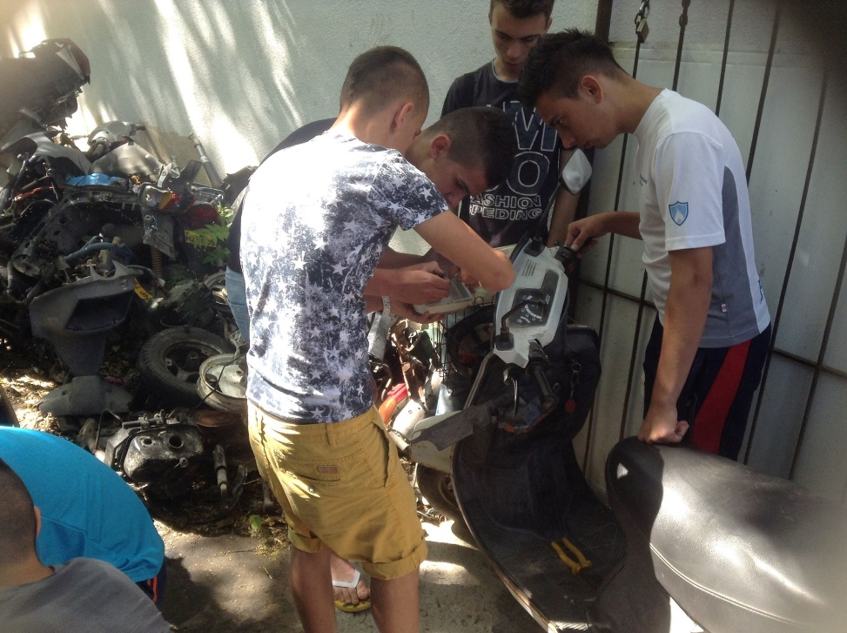
Figure 7 Practical training for young people in Cyprus

7. Motivating low qualified staff to pursue education - Cyprus experience
Issue at stake: Hotel staff with low level of education
Since tourism is one of the main sources of income in Cyprus, it is essential to raise qualification level of staff who work in this sector. Courses are available for tourism employees of all levels and most of them are at no extra cost for the employees. A big part of the National funds for lifelong learning goes to staff working in tourism and the Human Resources Development Authority of Cyprus offers many programs that are designed for hotel employees.
Some difficulties are experienced due to the mentality of employees with low qualification level who do not choose to follow any of the offered programs. This is especially true for lower income employees and temporary staff. In order to involve them in education it is important to convince them to follow the available courses.
One important target group was the hotel staff. OPEI aimed at helping them to use learning opportunities through available courses. OPEI was gradually convincing and involving them in education. First, they were offered to follow at least one compulsory seminar every season. The cooperation with the hotel management was crucial in this case. Those hotels who were open to cooperation agreed to allow their staff to attend a seminar during working hours.
The results were very encouraging. The trainer was constantly encouraging the hotel staff to attend free courses for professional development. As a result, many of them registered for language courses and courses for the development of their professional skills.
OPEI experience shows that low-skilled workers in the hotel industry require the appropriate encouragement to get involved in adult education. The work needs to be done in order to change the mentalities and help the hotel staff understand that it is never too late to learn. Learning to learn is the key.

8. Involvement of community theatre in adult education - Italian experience
Community theatre is a type of social work through theatre. NUCLEO (Teatro Nucleo) is exactly this type of theatre which was created in Argentina in the 1980’s and is currently located in Italy. It aims at the community integration through artistic activities such as acting, music, dance, costume and scenic design. It is based on the cooperation among representatives of different generations and on the idea of recovery of collective memory through specific techniques and exercises, the involvement of actors, musicians and other professionals of the performing arts.
In the course of its activities NUCLEO theatre developed a methodological framework for involving adults in education through drama. The projects of the theatre involve both the population and specialists of other domains, such as educators, psychologists, psychotherapists, psychiatrists, and social workers. These categories of professionals have experienced an increasing demand for intervention in difficult social situations that require strengthening the potential of human personality. This kind of projects allow for a broader use of the developed methodology creating favourable conditions for accessing education and motivating adults to get involved in it.
During project meetings, the participants use such work techniques as community songs and rhythm games, exercises of physical expression and dance, principles of scenic and costume design, puppets.
NUCLEO theatre works with such socially vulnerable groups as people with mental disabilities, prisoners, and elderly people. The experience of working with these groups has shown that the common problem shared by their members is low self-esteem. The opportunities to involve the population in the community life and education depend exactly on the solution of this problem.
In one of the projects, the theatre staged a play with prisoners because this is an opportunity for these people to feel free while being imprisoned. It gives them some hope for the future. Another project targets elderly people who learn to express themselves through movement, sound and communication. This project shows the importance of emotions in the learning process. By uncovering their own potential, the participants discover the world anew, which brings them to pursuing the educational path.

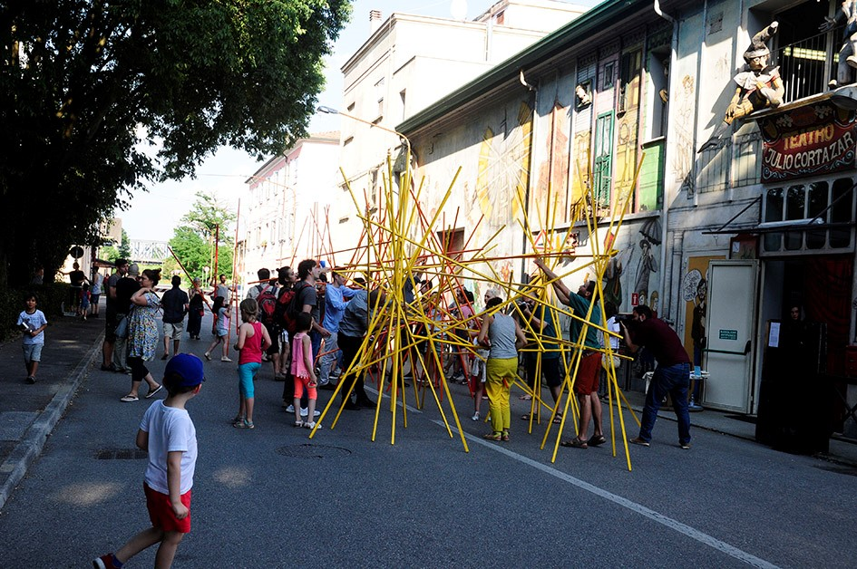
Figure 8Creation of a common installationduringthe TOTEM festival in Ferrara, 2017
Photo: L.Puķīna

9. Reaching parents through their children - Italian experience
NUCLEO theatre (Teatro Nucleo) has been actively involved in the integration of inhabitants of the local community. The theatre is located in Ferrara, a city with the multinational population which has recently faced an increase in the number of migrants. Many deprived members of the population live on the outskirts of the town and rarely visit its centre. Among the population there are people with fewer opportunities, as well as people with different religion. The composition of the community is very dynamic; its national and social diversity becomes the reason for the marginalisation of groups. At the same time, community welfare largely depends on the attitudes of its members. Therefore, promotion of community integration is one of the social problems addressed in the Emilia-Romagna region. Every year the Ministry of Culture allocates funding for addressing certain social priorities. NUCLEO theatre has been applying for this funding to develop relevant social projects.
The theatre has been carrying out projects with a drama method which is used in different ways. How can we bring people closer to each other if they do not trust members of other groups? NUCLEO theatre offers an interesting solution. A common value for the adults is their children. The theatre staged the play for children and also invited parents to attend it. The play addresses the problem of exclusion which is very topical for children. It involves children of various nationalities who come from neighbouring schools, including special schools. With the help of music, movement and video, the children reproduce different situations full of painful experiences and address the audience with a speech. The house is completely full, the old and the young, women and men, everyone is very emotional and wants to support children. This is an example of how cultural activities can make a practical contribution to social cohesion.

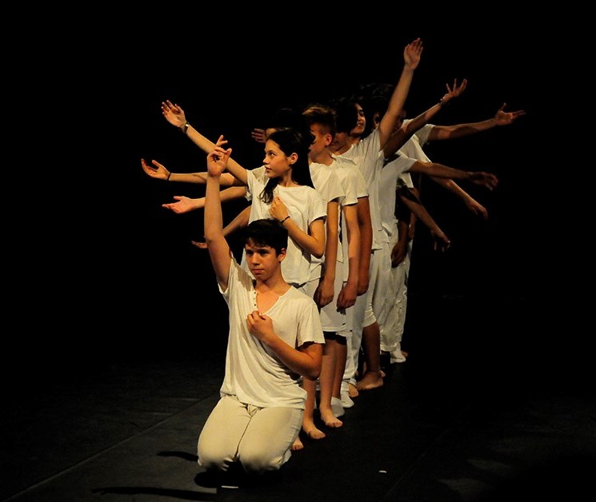
Figure 9Stage performance “The Big World” during the TOTEM festival in Ferrara that features children and young people, 2017
Photo: L.Puķīna

- Constructing future can encourage participation - Italian experience
One of the methods used by the NUCLEO theatre (Teatro Nucleo) is the Future lab’s method which is a participatory mean to identify utopias and resources in the community and to help the development of innovative social projects.
The methodology was conceived by a German, Robert Jungk, and it has been widely used in the Northern European countries for the planning and the improvement of services for citizens. It was developed in the 50s and was particularly related to the concern about the risk of increase of nuclear weapons. The aim of Robert Jungk was not just to protest against nuclear weapons, but also to promote and organize a “different future”.
Jungk considered that the educational processes anchor us to reality and we do not develop the habit of imagining the future and of thinking about our points of view. With the help of the Future lab method, Jungk wanted to give an opportunity to every person to feel they have resources for solving problems of their own territory.
NUCLEO theatre has been using and further developing the Future lab’s method. The participatory aspect of the method gives it an educational value, as well as allows achieving active participation of citizens in the improvement of services.
In collaboration with the city of Ferrara, the theatre organised three sessions of the FutureLab: 1) criticism / dystopia, 2) utopia, 3) the introduction of the proposals and of the feasibility analysis. The participants included adult citizens, elderly people, people with disabilities, and teenagers. One of the topics discussed in the FutureLab was “What are the faces of precariousness?” The participants expressed some criticism about the precarious daily life, as well as offered suggestions for improving the situation that could be useful for the development of social policies and shared services available to everyone.
Another session entitled “Saturday Wunderkammer Space in Via Darsena” became a sort of a time-machine, a window to a possible and, above all, desirable future.
A special atmosphere was created as a result of short moments of readings and theatrical improvisations organised in-between the sessions.
The FutureLab method allows to mobilise community resources in order to initiate new social projects in collaboration with policy makers. The participants develop their skills to express opinion, listen to others, critically assess information and develop productive proposals in collaboration with others. Thinking together and looking for new solutions for building a shared vision allows to destroy contradictions between the preconceived ideas and develop people’s sense of unity and participation.

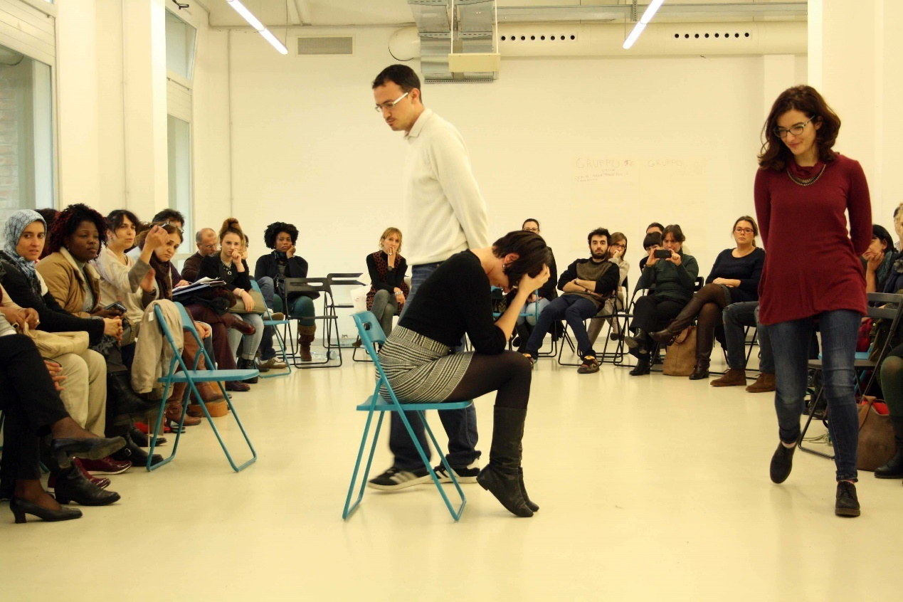
Figure 10The FutureLab in action

